Story Response - Maximum Story Displacement

Summary Description
This is story response output for a specified range of stories and a selected load case or load combination.

Input Data
Name | StoryResp2
Display Type | Max story displ | Story Range | All Stories
Load Case | RS | Top Story | Story6
Output Type | Not Applicable | Bottom Story | Base

Plot
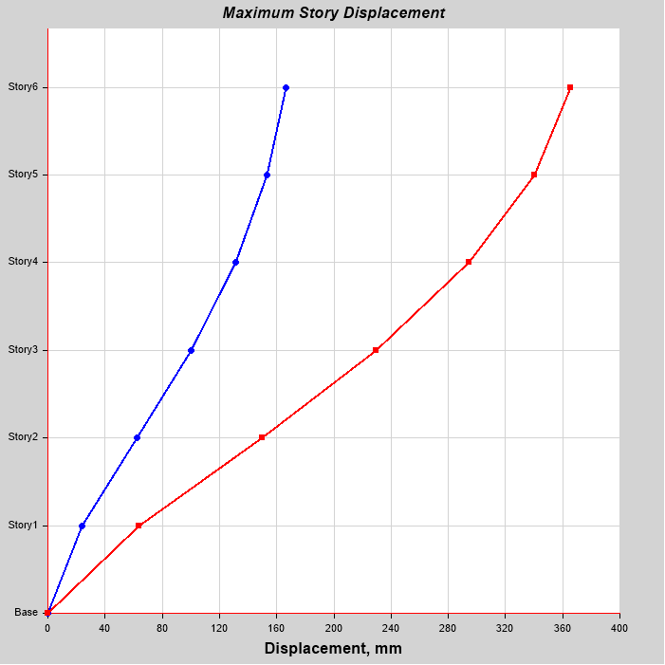

Tabulated Plot Coordinates
Story Response Values
Story | Elevation | Location | X-Dir | Y-Dir
 | m |  | mm | mm
Story6 | 18 | Top | 166.486 | 365.409
Story5 | 15 | Top | 153.459 | 340.4
Story4 | 12 | Top | 131.063 | 294.419
Story3 | 9 | Top | 100 | 229.628
Story2 | 6 | Top | 62.653 | 150.244
Story1 | 3 | Top | 23.977 | 63.441
Base | 0 | Top | 0 | 0

